Risk‑Signal Diversification: Combining Forward Model‑Implied Tail Risk with Realized‑Volatility Timing
The contribution is empirical risk‑signal diversification: we show that a forward, model‑implied tail‑risk timer (the posterior‑predictive CVaR of the held portfolio) and the standard backward, realized‑volatility timer (Moreira & Muir, 2017) carry distinct information and are complementary, so their multiplicative combination dominates either alone and the naive and optimized benchmarks out of sample. We do not claim that forward, options‑free tail‑risk forecasting is new (it is a mature field), nor that the Bayesian–CVaR allocator beats naive diversification. The study is framed as dynamic risk management of a long‑only ETF portfolio; the Bayesian–CVaR allocator is a building block. Empirical claims are made on risk‑adjusted terms with multiple‑testing‑aware inference; the complementarity result is the robust qualitative finding and the outperformance result is reported with explicit caveats.

1. Introduction and motivation
Two facts organise modern portfolio management. First, the cross‑sectional problem of choosing weights from estimated moments is dominated by estimation error. Optimized rules routinely fail to equal weight (1/N) strategies out of sample (DeMiguel, Garlappi & Uppal, 2009; Gelmini et al., 2024), a result theory rationalises in high dimensions (Yuan & Zhou, 2023). Second, the time‑series problem of scaling overall risk - "volatility timing" - can raise risk‑adjusted returns in sample (Moreira & Muir, 2017) but is fragile out of sample because the underlying predictive relationships are unstable (Cederburg, O'Doherty, Wang & Yan, 2020). A growing literature shows that tail‑based timing can improve on variance‑based timing (Rickenberg, 2020) and that combining risk forecasts dominates standalone forecasts (Happersberger, Lohre & Nolte, 2020).
This paper asks a focused, falsifiable question: does a forward, model‑implied tail‑risk signal add information beyond backward realized volatility, and are the two complementary? We construct the held portfolio's posterior‑predictive CVaR - a forward, model‑implied expected‑shortfall forecast drawn from a Bayesian scenario engine, use it to scale exposure, and test it head‑to‑head against, and in combination with, the Moreira–Muir realized‑volatility overlay. Our answer is nuanced: the forward signal is, on its own, weaker than realized‑volatility timing, but it is weakly correlated with it and therefore complementary; combining the two (de‑risk when either flags) beats either alone and beats 1/N and optimized Markowitz on risk‑adjusted terms.
We are explicit, following the closest prior art: forward, options‑free ES/CVaR forecasting is mature (Taylor, 2019; Le, 2020; Lyócsa et al., 2024); CVaR‑timing that beats volatility‑timing exists (Rickenberg, 2020); a forward tail‑risk timer benchmarked against Moreira–Muir exists (De Nicolò, 2023); and posterior‑predictive CVaR has been used for static allocation (Bodnar et al., 2022). Our marginal, defensible contributions are the conjunction of (i) a posterior‑predictive CVaR used as a timing signal (not a Logit/EVT forecast and not static allocation), drawn model‑consistently from the same scenario engine that defines the allocation constraint; (ii) an explicit test that this forward tail timer and the backward realized‑volatility timer are complementary, and that their multiplicative combination dominates either. This combination has not been tested in prior work, which either competes the two (De Nicolò, 2023), regime‑switches between them on a single asset (Rickenberg, 2020), or combines risk forecasts rather than two exposure timers (Happersberger et al., 2020); and (iii) a transparent allocation‑versus‑timing decomposition that locates the performance in the overlay rather than in security selection.

2. Theoretical framework and literature review
2.1 Portfolio selection, estimation error, and the naive‑diversification benchmark
Mean–variance optimisation (Markowitz, 1952) is undermined empirically by estimation error. DeMiguel, Garlappi & Uppal (2009) show that across fourteen optimised models and seven datasets none reliably beats 1/N; the result replicates on updated data (Gelmini et al., 2024), and Yuan & Zhou (2023) show 1/N is near‑optimal as dimensionality rises with diversifiable risk. Responses include parameter‑uncertainty shrinkage (Garlappi, Uppal & Wang, 2007; Lassance, Vrins & DeMiguel, 2024; Ban, El Karoui & Lim, 2018; Barroso & Nagel, 2021) and covariance shrinkage (Ledoit & Wolf, 2004). Thus, the cross‑sectional gains from optimisation are small and fragile, so we do not rest the contribution on security selection and treat 1/N (and optimised Markowitz) as the benchmarks to clear.
2.2 Coherent tail‑risk measures and the fragility of CVaR optimisation
The axiomatics of coherent risk measures (Artzner, Delbaen, Eber & Heath, 1999) motivated CVaR / expected shortfall, which is coherent and, for discrete scenarios, optimisable as a linear program via the Rockafellar–Uryasev representation (Rockafellar & Uryasev, 2000, 2001; Pflug, 2000; Mansini, Ogryczak & Speranza, 2007). Crucially, CVaR optimisation is coherent but fragile: because the estimate uses only tail scenarios, optimal CVaR portfolios are highly sensitive to estimation error, which optimisation magnifies and heavier tails worsen (Lim, Shanthikumar & Vahn, 2011); robustified variants only partially repair this (Gotoh, Takeda & Yamamoto, 2013; Nakagawa, Kawahara & Ito, 2021). This is the theoretical justification for using the posterior‑predictive CVaR primarily as a forecast/ timing signal rather than as the engine of cross‑sectional weight selection.
2.3 Risk timing: volatility‑managed portfolios and their out‑of‑sample fragility
Moreira & Muir (2017) show that scaling exposure inversely to recent realized variance raises factor Sharpe ratios, because volatility is more forecastable than the premium. The result is contested out of sample: Cederburg et al. (2020) find the implied real‑time rules generally do not beat the unmanaged portfolios, owing to structural instability; refinements that survive better include downside‑ volatility scaling (Wang, Yan & Zheng, 2021) and conditional multifactor formulations (DeMiguel et al., 2024). This motivates asking whether a different kind of risk signal - forward and tail‑focused - adds information to backward variance.
2.4 Forward‑looking risk forecasting is mature and not option‑dependent
We emphasise - correcting a common framing - that forward, model‑based tail‑risk forecasting is a large mature literature that does not require options. Joint VaR/ES is forecast via asymmetric‑Laplace / ES‑CAViaR scoring (Taylor, 2019), MIDAS (Le, 2020), and GARCH‑EVT / dynamic semiparametric quantile models. Option‑implied information can time risk (Kostakis, Panigirtzoglou & Skiadopoulos, 2011; Kita & Tu, 2023; Bianchi, Tassinari & Fabozzi, 2018), but Lyócsa et al. (2024) find implied volatility is largely irrelevant for ES forecasting relative to econometric models. Hence "forward" and "options‑free" are established properties, not contributions of this paper. Our forward signal is distinguished only by being a Bayesian posterior‑predictive CVaR of the held portfolio, integrating parameter uncertainty (Bauder et al., 2018; Bodnar et al., 2022), used for timing.
2.5 Tail‑risk timing, forecast combination, and the closest prior art
A recent literature times a tail measure directly and is the immediate predecessor of this study. Rickenberg (2020) shows downside/CVaR targeting outperforms volatility targeting on Sharpe, drawdown, and utility, and that switching between volatility‑ and CVaR‑targeting by regime improves results — establishing forward CVaR‑based exposure timing and a conditional blend of the two, on a single risky asset using EVT/GARCH tail forecasts. De Nicolò (2023) constructs tail‑risk‑managed portfolios whose factor exposures scale with forecast VaR‑violation probabilities (a frequentist Logit forecaster) and shows they beat both buy‑and‑hold and Moreira–Muir volatility‑managed portfolios net of costs - establishing a forward, options‑free tail timer benchmarked head‑to‑head against Moreira–Muir, with volatility management treated as a competing benchmark. Happersberger, Lohre & Nolte (2020) show that combining expected‑shortfall forecasts dominates standalone forecasts within a tail‑protection overlay. Schwalbach & Auret (2023) show two complementary defensive overlays (option hedging and trend‑following) outperform either alone, using traded options and trend rather than a tail forecast and realized vol. Finally, Bodnar et al. (2022) derive VaR/CVaR‑optimal weights from the posterior‑predictive distribution but for static allocation, not timing. These papers occupy most of the "forward tail timing vs realized‑vol timing" ground; our contribution is stated narrowly against them.
2.6 Out‑of‑sample inference and the multiple‑testing problem
Backtested performance is inflated by selection over trials. We adopt the Deflated Sharpe Ratio, which corrects the observed Sharpe for the number of configurations tried, non‑normality, and sample length (Bailey & López de Prado, 2014), within the broader multiple‑testing programme (Harvey, Liu & Zhu, 2016; Suhonen, Lennkh & Perez, 2017; Wiecki et al., 2016), together with paired stationary‑bootstrap tests. We deflate over the strategy‑selection trials from which the reported strategy was chosen (overlay forms, target levels, and combination rules), excluding the naive/Markowitz benchmarks.

3. Research gap
The three relevant literatures are adjacent but leave a specific space unoccupied:
- Volatility timing is backward‑looking and fragile out of sample (Moreira & Muir, 2017; Cederburg et al., 2020).
- Forward tail‑risk timing exists, but in prior work it is frequentist (Logit on VaR‑violation probabilities — De Nicolò, 2023; EVT/GARCH CVaR targets — Rickenberg, 2020), is applied to factors or a single asset, and treats volatility management as a competing benchmark or a regime switch rather than a complement.
- Posterior‑predictive CVaR is used only for static allocation (Bodnar et al., 2022)
The gap. No prior study uses a Bayesian posterior‑predictive CVaR of the held portfolio, model‑consistent with its allocation constraint, as a forward exposure timer, nor tests whether such a forward tail timer is complementary to backward realized‑volatility timing such that their multiplicative combination dominates either alone on a broad long‑only ETF cross‑section.
3.1 Relation to the closest prior work
Prior work | What it establishes | Significance for this study
De Nicolò (2023) - Tail‑Risk‑Managed Portfolios | Forward, options‑free tail timer (Logit VaR‑violation), beats Moreira–Muir on factors | Frequentist Logit vs Bayesian posterior‑predictive; factor exposures vs long‑only ETF book; vol‑management competed, not combined
Rickenberg (2020) - Target VaR/CVaR | CVaR targeting > vol targeting; regime switch between them | EVT single asset vs multi‑asset posterior‑predictive; regime switch vs multiplicative product of de‑risk fractions
Happersberger et al. (2020) | Combining ES forecasts dominates standalone | Combines risk forecasts; we combine a forward tail timer with a backward vol timer (two exposure scalers of different provenance)
Bodnar et al. (2022) | Posterior‑predictive VaR/CVaR allocation | Static allocation only; we use posterior‑predictive CVaR for dynamic timing
Moreira & Muir (2017); Cederburg et al. (2020) | Realized‑vol timing; OOS fragility | We add a forward, complementary signal and test the combination

We therefore re‑state model‑consistency as a coherent design principle (the same posterior‑predictive scenarios define the constraint and the timer), and we rest the empirical contribution on complementarity and combination.

4. Research questions and hypotheses
- RQ1 (signal validity). Is the forward, model‑implied posterior‑predictive CVaR of the held portfolio a causal, informative predictor of subsequent realized losses?
H1: CVaR_model,t is positively associated with next‑period realized loss.

- RQ2 (the core - complementarity). Is the forward tail timer complementary to backward realized‑volatility timing, and does each, alone, improve risk‑adjusted performance over the unmanaged book?
H2a: each overlay raises risk‑adjusted performance;
H2b: the two implied exposure paths are weakly correlated (distinct information);
H2c: the forward signal alone need not beat realized vol

- RQ3 (combination & outperformance). Does the multiplicative combination (de‑risk when either flags) dominate (i) each signal alone, (ii) 1/N, and (iii) optimised Markowitz, out of sample?
H3: the combination attains the highest Sharpe, Sortino, and Calmar and the shallowest drawdown; the improvement is statistically significant on drawdown / downside metrics and on a Deflated‑Sharpe basis, while the Sharpe‑level improvement over the realized‑volatility overlay is positive but, on this short sample, not decisively significant - i.e. the combination's edge is primarily one of downside risk control.

- RQ4 (decomposition). How much of performance is allocation (selection) versus timing?
H4: the allocator's selection is not reliably distinguishable from 1/N; the incremental performance is attributable to the risk‑timing overlay.

5. Methodology and research design
Monthly, walk‑forward out‑of‑sample backtest over a liquidity‑screened U.S.‑ETF universe (≈220 names/month), 2019–2025 (83 months), long‑only.
5.1 Data and universe
The study uses daily total‑return series for U.S.‑listed exchange‑traded funds (ETFs), with daily opening/closing prices and share volumes, over 2016–2025; the three‑year burn‑in yields an out‑of‑sample window of 83 months, 2019–2025. Returns are point‑in‑time, the investable universe is re‑screened each month, and the strategy rebalances on the first business day of every month. Over the out‑of‑sample window the screen admits a median of 242 ETFs per month (range 211–254), rising from 211 in early 2019 to ≈240 by 2025 as more funds accumulate sufficient trading history (Figure 1).

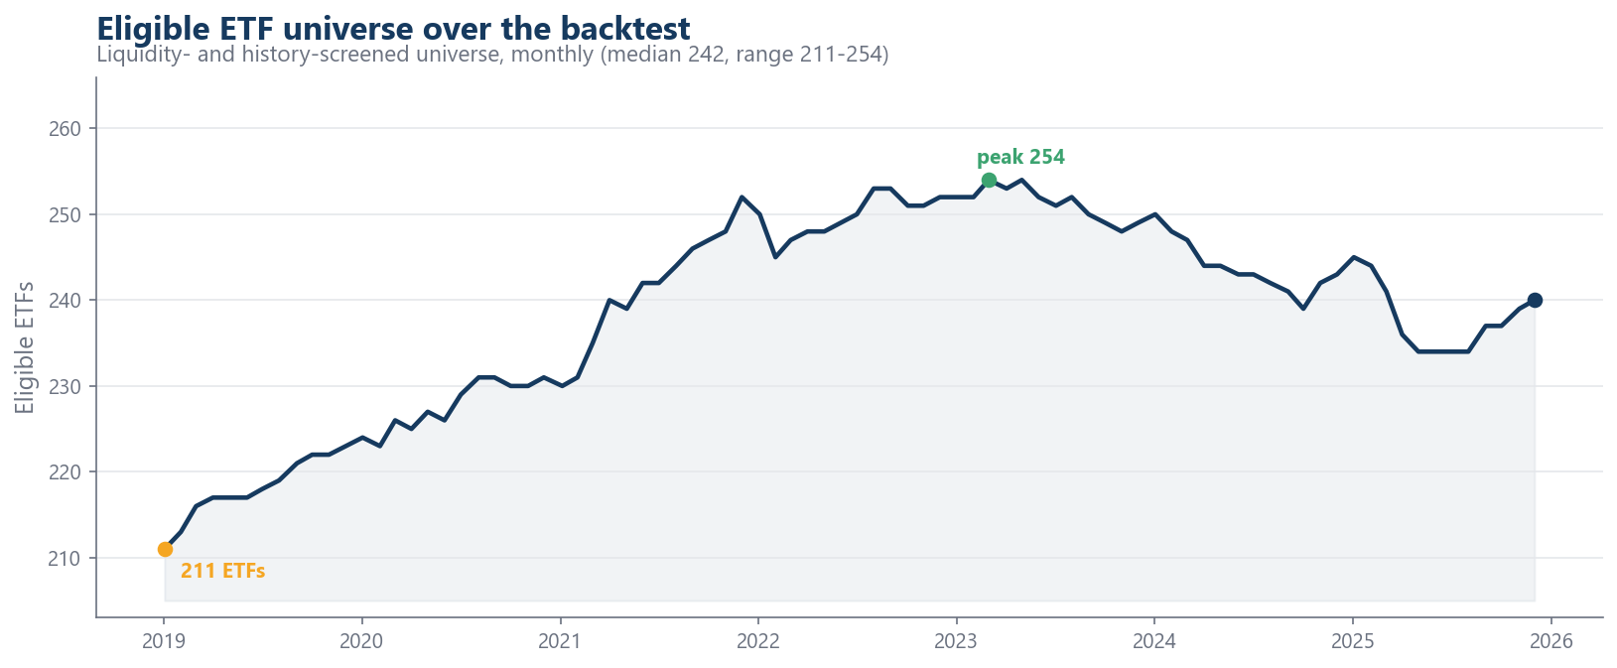
Figure 1. Number of eligible ETFs per month over the backtest (liquidity and history screened universe).

Filtering procedure
The eligible universe is built by a causal liquidity and history screen applied each month. For every ETF a daily dollar‑volume proxy is formed as the mid‑price times share volume.

$${ADV}_{t}=\left(\frac{P_{t}^{open}+P_{t}^{close}}{2}\right)V_{t}$$
This proxy is then summed within each U.S. business month to a monthly dollar volume.
$${MDV}_{i,m}=\sum_{t∈m}{{ADV}_{i,t}}$$

An ETF is eligible in month t only if both conditions hold: (i) a continuous‑history requirement - the fund must have traded in each of the trailing 36 months, guaranteeing at least three years of data to match the estimation lookback; and (ii) a liquidity requirement - the fund's 36‑month rolling‑mean monthly dollar volume, expressed as a share of the aggregate dollar volume across all funds must exceed a threshold of 0.005% of market dollar volume. The threshold is calibrated to retain approximately 220 most liquid, established funds.
5.2 Bayesian posterior‑predictive scenario engine
Each month, on a rolling three‑year window, the model produces an (S × N) matrix of S = 1000 distinct next‑period scenarios.
$$R=1_{S} μ_{post}^{⊤}+ZL^{⊤}$$
μ_post is a per‑ETF posterior mean under a horseshoe prior (Carvalho, Polson & Scott, 2010) plus a cross‑sectional momentum tilt, and $LL^{⊤}=Σ$the Cholesky factor of the Ledoit–Wolf covariance (Ledoit & Wolf, 2004).
The allocator's risk constraint is a CVaR (expected shortfall) - an average over the worst tail of outcomes. A tail measure is only defined relative to a distribution of next-period returns, not a point forecast. The engine therefore produces, each month, a Monte-Carlo sample of S = 1000 plausible next-month return vectors for the N eligible ETFs. The empirical α-tail of the portfolio's returns across those S scenarios is what makes CVaR estimable and the constraint meaningful. (This is also why the rows must be distinct: if all rows were identical, the α-tail would equal the mean and "CVaR" would collapse to expected return — the degenerate case the fix removed.)
The posterior predictive scenario set is the forward, model-implied distribution that does double duty: it defines the allocation constraint and it is the object whose tail we later read off as the forward timing signal (CVaR of the held book).
Step 1 The per-ETF predictive mean μ_post
For each ETF i, on the rolling window of T ≈ 756 daily returns r_{i,t}, three quantities are combined.
- Sample mean and a per-ETF prior
The data estimate is the window mean; the prior is each ETF's own EWMA-of-returns mean (not a single global grand mean), so the shrinkage target preserves cross-sectional information:
$${\overset{ˆ}{μ}}_{i}^{sm}=\frac{1}{T}\sum_{t=1}^{T}{r_{i,t}}$$
$$m_{i}^{0}=\frac{1}{T}\sum_{t=1}^{T}{{\tilde{r}}_{i,t}}$$

where r̃_{i,t} is the EWMA-smoothed return series.

- Horseshoe-style adaptive shrinkage
The horseshoe prior (Carvalho, Polson & Scott, 2010) places heavy-tailed half-Cauchy priors on a global scale τ and local scales λ_i; their product governs how much each coefficient is shrunk. We draw these scales and form a per-ETF shrinkage weight κ_i ∈ (0,1) (the weight on the data), floored at κ_min = 0.5 so genuine cross-sectional signal is not over-shrunk:
$$τ_{i}, λ_{i}\sim \left|C(0,1)\right|, clipped to [0.01,5]$$
$$κ_{i}=clip \left(\frac{τ_{i}λ_{i}}{1+τ_{i}λ_{i}}, κ_{min}, 1\right)$$
$$κ_{min}=0.5$$
$${\overset{ˆ}{μ}}_{i}^{shr}=κ_{i}{\overset{ˆ}{μ}}_{i}^{sm}+(1-κ_{i})m_{i}^{0}$$

- Cross-sectional momentum tilt
A 12-minus-1-month cumulative return is computed (skipping the last 21 days to avoid short-term reversal), z-scored across ETFs, and scaled to return units by the typical daily volatility, then added with weight θ = 0.3:

$$g_{i}=\sum_{t=T-252}^{T-21}{r_{i,t}}$$
$$z_{i}=\frac{g_{i}-\bar{g}}{sd(g)}$$
$$σ^{*}={median}_{i} \left({sd}_{t}(r_{i,t})\right)$$
$$μ_{i}^{post}={\overset{ˆ}{μ}}_{i}^{shr}+θz_{i}σ^{*}, θ=0.3$$

Step 2 - the covariance Σ and its Cholesky factor
The second moment is estimated with the Ledoit–Wolf shrinkage estimator: a convex combination of the noisy sample covariance S and a structured target F (a scaled-identity / constant-correlation matrix), with the intensity δ⋆ ∈ [0,1] chosen to minimise expected Frobenius loss:
$$S=\frac{1}{T-1}\sum_{t=1}^{T}{\left(r_{t}-\bar{r}\right){\left(r_{t}-\bar{r}\right)}^{⊤}}$$
$$Σ=(1-δ^{⋆})S+δ^{⋆}F$$
Σ is then projected to the nearest valid positive-semidefinite matrix and factorised by Cholesky into a (lower-triangular) L:
$$Σ=LL^{⊤}$$
With N ≈ 220 assets and T ≈ 756 days the sample covariance is noisy and ill-conditioned; Ledoit–Wolf shrinkage stabilises it (and guarantees invertibility), which matters because the correlation structure in L is what makes the simulated joint downside realistic - tail co-movement, not just marginal volatilities, drives portfolio CVaR.

Step 3 — drawing the posterior predictive scenario set
Draw a standard-normal matrix Z ∈ ℝ^{S×N} (optionally a scaled Student-t_ν for heavier tails), color it with the Cholesky factor, and add the mean:
$$Z∈R^{S×N}, Z_{s,j}\overset{iid}{\sim }N(0,1)$$
$$R=1_{S} μ_{post}^{⊤}+ZL^{⊤}∈R^{S×N}$$
Each row is therefore an independent draw from a multivariate normal centred at the predictive mean with the shrinkage covariance:
$$R_{s,:}=μ_{post}^{⊤}+Z_{s,:}L^{⊤}$$
$$R_{s,:}\overset{iid}{\sim }N \left(μ_{post}, Σ\right), s=1,…,S$$

S = 1000 distinct rows give a genuine empirical distribution with a populated tail.

How the the posterior predictive scenario set is consumed (CVaR)
For any weight vector w, the S scenario portfolio returns are Rw; the losses are their negatives, and CVaR at level α is the mean of the worst (1−α) fraction:
$$l_{s}=-R_{s,:}w$$
$${VaR}_{α}=Q_{α} \left(\{l_{s}\}\right)$$
$${CVaR}_{α}(w)=\frac{1}{\left|\{s:l_{s}≥{VaR}_{α}\}\right|}\sum_{s: l_{s}≥{VaR}_{α}}{l_{s}}$$
With α = 0.95 and S = 1000, this averages the worst 50 scenarios - exactly the quantity the Rockafellar–Uryasev LP constrains in the allocator and that we later read off the held book as the forward timing signal.

On parameter uncertainty
Conceptually the target is the posterior-predictive distribution
$$p(R_{next}data)=∫p(R_{next}μ,Σ) p(μ,Σdata) dμ dΣ$$
i.e. averaging the return distribution over the uncertainty in the parameters (Bauder et al., 2018; Bodnar et al., 2022). In our implementation this is realised approximately: estimation uncertainty is handled through the shrinkage estimators (horseshoe for μ, Ledoit–Wolf for Σ), which pull noisy estimates toward stable targets, while the S rows sample the return/innovation uncertainty Z around those estimates. So the engine is a shrinkage-based predictive sampler rather than a full posterior integrator. The framing in the paper is that parameter uncertainty enters via shrinkage, and the posterior predictive scenario set supplies the return distribution needed to make CVaR operational.

Dynamic optimizer parameters and execution
Two elements of the pipeline are state-dependent and recomputed, causally, at every monthly rebalance.
Dynamic-parameter controller
Before the optimiser runs, a controller sets the CVaR confidence level α and the L1 turnover penalty λ from a single bounded score that blends the strategy's own recent performance with a market-regime gauge:
$$s_{t}=0.70 p_{t}+0.30 g_{t}∈[-1,1]$$
Here p_t summarises the portfolio's recent realised returns - a capped win/loss-streak term plus an EWMA Sharpe of past monthly returns, squashed (through tanh) as the raw score is passed through the hyperbolic-tangent function, which compresses any input into the bounded range (−1, +1):
$$p_{t}=tanh(0.55 \frac{{streak}_{t}}{6}+0.35 \frac{{\bar{r}}_{t}^{ewma}}{{\overset{ˆ}{σ}}_{t}^{ewma}})$$
and g_t ∈ [−1,1] is a market-regime gauge formed from the cross-section's daily returns and a dollar-volume liquidity proxy: a weighted combination of 63-day market momentum, breadth (share of assets with positive momentum), and a liquidity trend, minus the 21-/126-day volatility ratio, the 252-day drawdown, and average pairwise correlation ("correlation stress"). The score then moves the two parameters around their base values:
$$α_{t}=clip(α_{0}-0.05 s_{t}, 0.90, 0.995)$$
$$λ_{t}=clip(λ_{0}exp(0.55 s_{t}), 0.01, 10)$$
A risk-off state (negative s_t) therefore raises α - pushing the CVaR measure deeper into the tail and, because α also defines the self-scaling budget c = κ·CVaR_α(1/N), tightening the constraint toward a more tail-robust allocation -and lowers λ, making it cheaper for the optimiser to re-trade out of risk. A calm state does the reverse. The performance and regime states (the streak, the EWMAs, and the rolling regime statistics) use only information available at the rebalance date, so α_t and λ_t are strictly causal.
Dynamic execution (partial rebalancing)
Trades toward the optimiser's target are then executed only partially. Rather than jumping w_t^{target}, the held book moves a fraction a_t of the way:
$$w_{t}^{exec}=w_{t-1}+a_{t}(w_{t}^{target}-w_{t-1}), a_{t}∈[0,1]$$
where a_t is a sigmoid of trailing performance. This smooths the path of the portfolio and contains turnover and transaction costs while leaving the optimiser's intended composition intact.
The allocation objective itself is held fixed across the backtest (maximum expected return subject to the CVaR constraint), so only α, λ, and the execution fraction a_t vary over time.

5.3 Allocator: maximum return subject to a CVaR constraint
Monthly weights solve the Rockafellar–Uryasev LP:
$$\max_{w} μ·w$$
$$s.t. {CVaR}_{α}(w)≤c$$
$$∑w=1$$
$$0≤w≤0.12$$
$$-λ\left\|w-w_{prev}‖_{1}\right.$$
$$α=0.95, c=κ·{CVaR}_{α}(1/N)$$
with L1 turnover penalty (Rockafellar & Uryasev, 2000; Mansini et al., 2007). Per the fragility result (Lim et al., 2011), the allocator's selection is a building block, tested against 1/N in RQ4 and is not a source of claimed alpha.
5.4 Risk‑timing overlays
Exposure is scaled by k_t ∈ [k_min, 1], the de-risked fraction (1 − k_t) held at the risk-free rate:
- Backward -realized volatility
A trailing 21-day realized volatility of the reconstructed book is used with a fixed causal target σ* = 12% (Moreira & Muir, 2017).
$$k_{t}^{RV}=clip(σ^{*}/{\overset{ˆ}{σ}}_{t}, k_{min}, 1)$$
- Forward - model‑implied CvaR
The held book's posterior-predictive expected shortfall is read from the same posterior predictive scenario set used for allocation.
$${CVaR}_{model,t}={CVaR}_{α}(pred_returns·w_{target})$$
$$k_{t}^{CV}=clip({CVaR}_{t}^{*}/{CVaR}_{model,t}, k_{min}, 1)$$
The self-scaling target CVaR*_t is the causal expanding-window median of the forecast series, computed using information through month t only - not the full-sample median - with a short burn-in.

- Combination
The strategy de-risks when either signal flags; the product form, a convex blend, and a causally adaptive weight are compared at matched average exposure (Happersberger et al., 2020; Schwalbach & Auret, 2023).

$$k_{t}^{COMB}=clip(k_{t}^{RV}·k_{t}^{CV}, k_{min}, 1)$$

5.5 Benchmarks
On the identical universe, dates, and realized returns: 1/N (DeMiguel et al., 2009) and Markowitz maximum‑Sharpe and minimum‑variance with Ledoit–Wolf covariance, long‑only, same cap and proportional cost.
5.6 Performance evaluation and statistical inference
Metrics: annualised return/volatility, Sharpe, Sortino, maximum drawdown, Calmar, monthly CVaR.
Inference: the Probabilistic Sharpe Ratio (trial-independent; non-normality and sample length) and the Deflated Sharpe Ratio, the latter deflated over the set of strategy-selection variants actually searched (overlay forms, target levels, and combination rules -the naive and Markowitz benchmarks are excluded from the trial-variance, as they are comparators rather than trials of the strategy) (Bailey & López de Prado, 2014; Harvey, Liu & Zhu, 2016); and paired stationary-bootstrap tests (5,000 resamples) for the Sharpe and maximum-drawdown differences (combination vs realized-vol baseline; each model arm vs 1/N).
RQ1 is tested by the causal correlation of
$${CVaR}_{model,t}$$
with next-month realized loss and a predictive plot around drawdown episodes.
RQ2b is tested by the correlation of the two implied exposure paths:
$$corr(k^{RV}, k^{CV})$$
5.7 Robustness
(i) Allocation‑vs‑timing decomposition (RQ4) against 1/N and inverse‑volatility. (ii) Combination form at matched average exposure (product vs convex blend vs causally‑adaptive weight). (iii) Causal‑target verification: the headline is re‑estimated with the causal expanding‑median CVaR*_t (vs a full‑sample median) to confirm the result is not look‑ahead‑driven. (iv) Alternative eligibility universes of differing breadth.

6 Results
All results are out-of-sample over the 83-month window 2019–2025, computed net of a proportional transaction cost. We report eight strategies side by side:
- the allocator alone (Static)
- the allocator with the dynamic-parameter controller (Dynamic base)
- the two single overlays: realized-volatility (backward) and model-CVaR (forward)
- the combined overlay (the managed portfolio)
- three external references: the 1/N equal-weight rule and Markowitz maximum-Sharpe and minimum-variance portfolios built on the same universe.
The headline pattern is one of risk transformation rather than return enhancement. Moving down the ladder from the unmanaged allocator to the combined overlay leaves annualized return broadly intact (9.3–11.3%) but compresses risk sharply: annualized volatility falls from 13.4% to 8.3%, the maximum drawdown shrinks from −19.3% to −7.3%, and monthly CVaR₉₅ roughly halves. The combined arm therefore records the best risk-adjusted profile in the comparison (Sharpe 0.867, Sortino 1.74, Calmar 1.27) and the lowest tail risk, while the two single signals sit between the unmanaged book and the combination. Because the sample is a predominantly rising market, this risk reduction is bought at the cost of terminal wealth: the managed arm compounds to a lower balance than the unmanaged book or 1/N (Figure 6.1). However, it delivers its return far more efficiently per unit of risk and with much shallower losses.
Two reference results anchor the interpretation. First, the allocator's security selection is statistically indistinguishable from naïve diversification: the Static arm's Sharpe (0.624) is within noise of 1/N (0.622), consistent with the well-documented difficulty of beating the equal-weight rule out of sample. Second, optimised Markowitz fails, as estimation error predicts - its maximum-Sharpe and minimum-variance portfolios earn Sharpe ratios of 0.27 and ≈0, compounding to only +26% and +15%. The value added in this study is therefore located not in the cross-sectional weights but in the time-series risk overlay, and specifically in the complementarity of the forward and backward risk signals. Their implied exposure paths are only weakly correlated (ρ ≈ 0.17), so de-risking when either flags captures distinct danger episodes and yields the shallowest drawdowns of any arm.
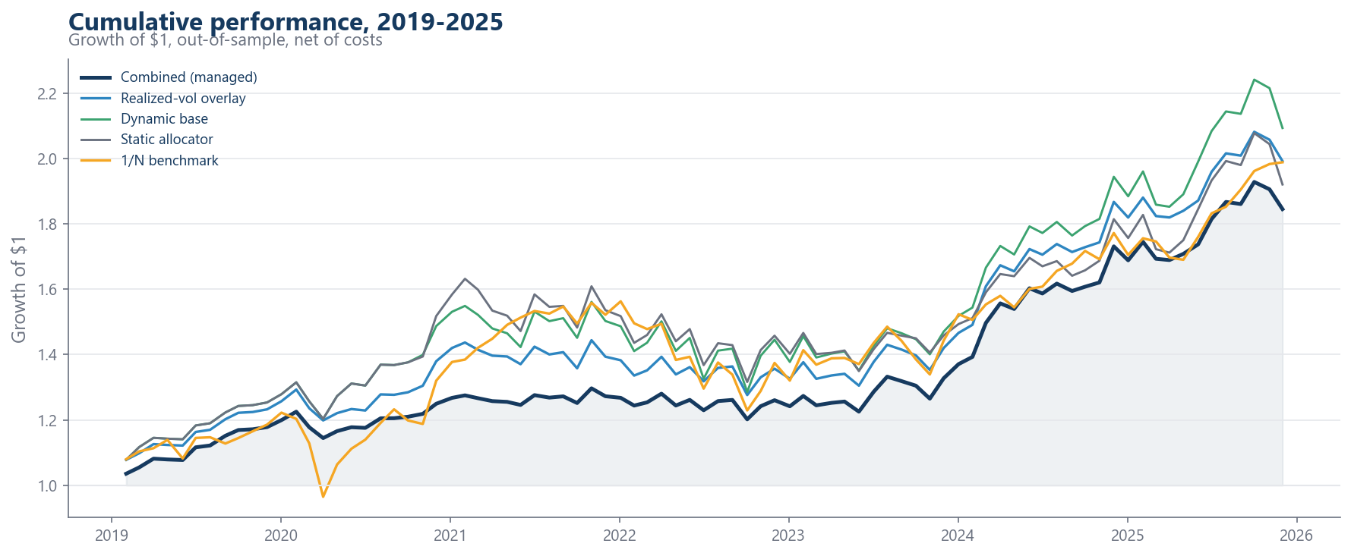
Figure 6.1. Growth of $1, out-of-sample and net of costs. The combined managed portfolio compounds below the unmanaged and naïve books in a bull market but with materially lower volatility and drawdown.

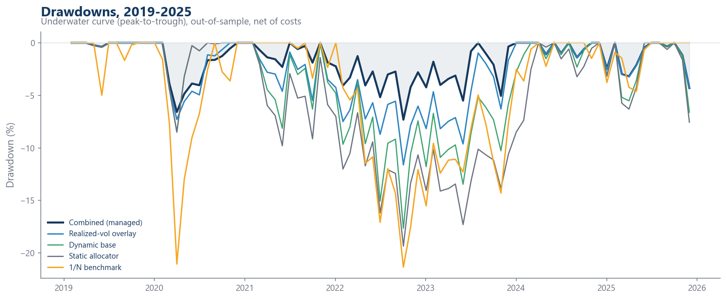

Strategy | Cumul % | Ann % | Vol % | Sharpe | Sortino | Max DD % | Calmar | CvaR 95% | PSR %
Static allocator (no overlay) | 92.0 | 9.89 | 13.40 | 0.624 | 1.02 | −19.34 | 0.51 | −6.51 | 94.5
Dynamic base (controller on) | 109.3 | 11.27 | 13.70 | 0.704 | 1.13 | −17.64 | 0.64 | −6.93 | 96.3
+ Realized-vol overlay (backward) | 99.2 | 10.48 | 10.35 | 0.824 | 1.61 | −11.61 | 0.90 | −4.38 | 98.4
+ Model-CVaR overlay (forward) | 90.5 | 9.77 | 10.77 | 0.736 | 1.16 | −11.97 | 0.82 | −5.76 | 96.8
+ Combined (managed portfolio) | 84.5 | 9.26 | 8.33 | 0.867 | 1.74 | −7.31 | 1.27 | −3.56 | 98.9
Benchmark 1/N | 98.4 | 10.41 | 14.44 | 0.622 | 0.82 | −21.36 | 0.49 | −8.71 | 93.7
Benchmark Markowitz max-Sharpe | 26.0 | 3.40 | 5.57 | 0.270 | 0.26 | −15.45 | 0.22 | −3.85 | 75.0
Benchmark Markowitz min-variance | 14.6 | 1.99 | 1.68 | −0.01 | 0.00 | −5.18 | 0.39 | −1.30 | 49.4
PSR = Probabilistic Sharpe Ratio (probability the true Sharpe exceeds zero, adjusted for non-normality and sample length).
Table 6.2 reports four further risk ratios. Treynor is annualised excess return per unit of market. Downside deviation is the annualised dispersion of below-zero monthly returns. The pain ratio is annualised excess return divided by the average drawdown depth, the mean of the underwater curve rewarding strategies that spend little time and depth below their peak. MAD is the mean absolute deviation of monthly returns, a fat-tail-robust dispersion measure. All four move monotonically as the overlay engages: downside deviation and MAD roughly halve, while Treynor (15.5 - 24.6) and the pain ratio (1.55 - 4.47) rise sharply. The combined arm earns the most return per unit of market risk and per unit of drawdown pain, and dominates the 1/N benchmark on every one.
Table 6.2 - Additional risk ratios.
Strategy | Treynor % | Downside dev % (ann.) | Pain ratio | MAD % (monthly)
Static allocator | 15.5 | 8.04 | 1.55 | 3.14
Dynamic base | 17.3 | 8.20 | 2.50 | 3.20
+ Realized-vol overlay | 22.4 | 5.53 | 3.17 | 2.40
+ Model-CVaR overlay | 18.8 | 6.40 | 3.64 | 2.50
+ Combined (managed) | 24.6 | 4.28 | 4.47 | 1.92
Benchmark 1/N | 11.0 | 9.27 | 1.93 | 3.14

Statistical significance
The combined arm's improvements are tested with a paired stationary bootstrap (5,000 resamples) on the common months, and with the Deflated Sharpe Ratio (DSR), which discounts the observed Sharpe for multiple testing.
Comparison (treatment = Combined) | Δ Sharpe | P(better) | Δ MaxDD | P(shallower)
vs Realized-vol overlay | +0.043 | 0.69 | +0.043 | 0.99
vs 1/N | +0.245 | 0.78 | +0.141 | 0.99
vs Dynamic base | +0.163 | 0.87 | +0.103 | 1.00

The reduction in maximum drawdown is statistically robust: in 99–100% of the bootstrap resamples the combined portfolio sustains a shallower worst-case loss than the comparator. The improvement is therefore very unlikely to reflect the particular path this sample happened to take, and instead appears to be a genuine property of the strategy.
The evidence on risk-adjusted return is favourable in level terms but weaker in significance. Two selection-aware statistics speak to whether the combined arm's Sharpe ratio is genuine rather than a product of chance. Its Probabilistic Sharpe Ratio - the probability that the true Sharpe ratio is positive once the short sample and the non-normality of returns are accounted for - is 98.9%. Its Deflated Sharpe Ratio, which additionally penalizes the Sharpe for the number of strategy configurations explored during the research, is 95.8%. Both clear the conventional 95% threshold, indicating that the positive performance is unlikely to be an artefact of either estimation noise or data-mining. The deflated figure is, moreover, insensitive to the exact trial count - it stays in the 96–97% range whether ten or forty configurations are counted - because the deflation is governed mainly by the small dispersion of Sharpe ratios across the genuine strategy variants (the external 1/N and Markowitz portfolios are comparators).
What the data do not support is a claim of superior risk-adjusted return over the simpler realized-volatility overlay: the Sharpe-ratio difference of +0.04 is positive but falls well short of significance, with the combined arm superior in only 69% of resamples. The honest interpretation is therefore that the strategy's contribution is downside-risk control - a statistically significant reduction in tail losses - rather than a decisive gain in risk-adjusted return.
Portfolio composition and concentration
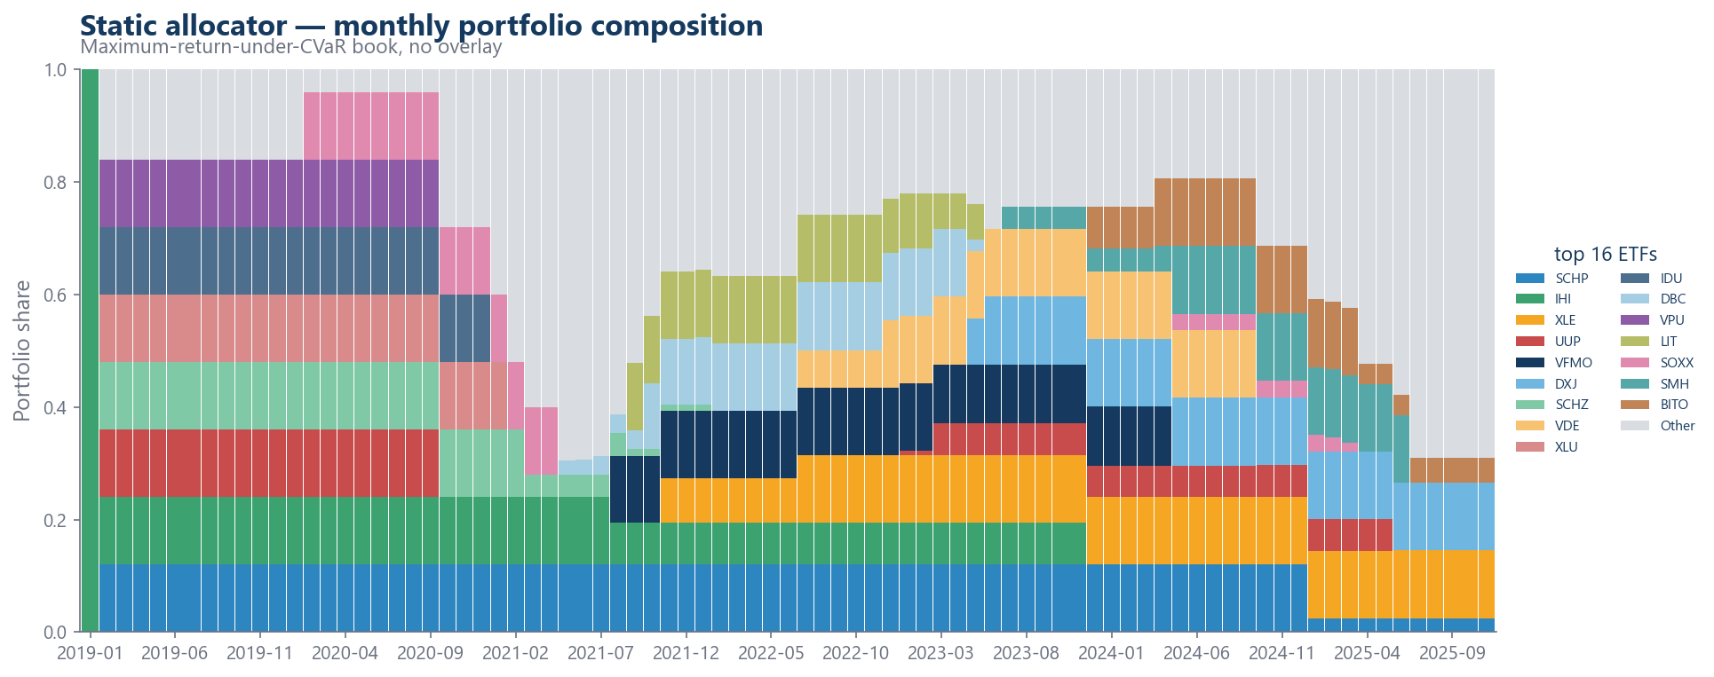

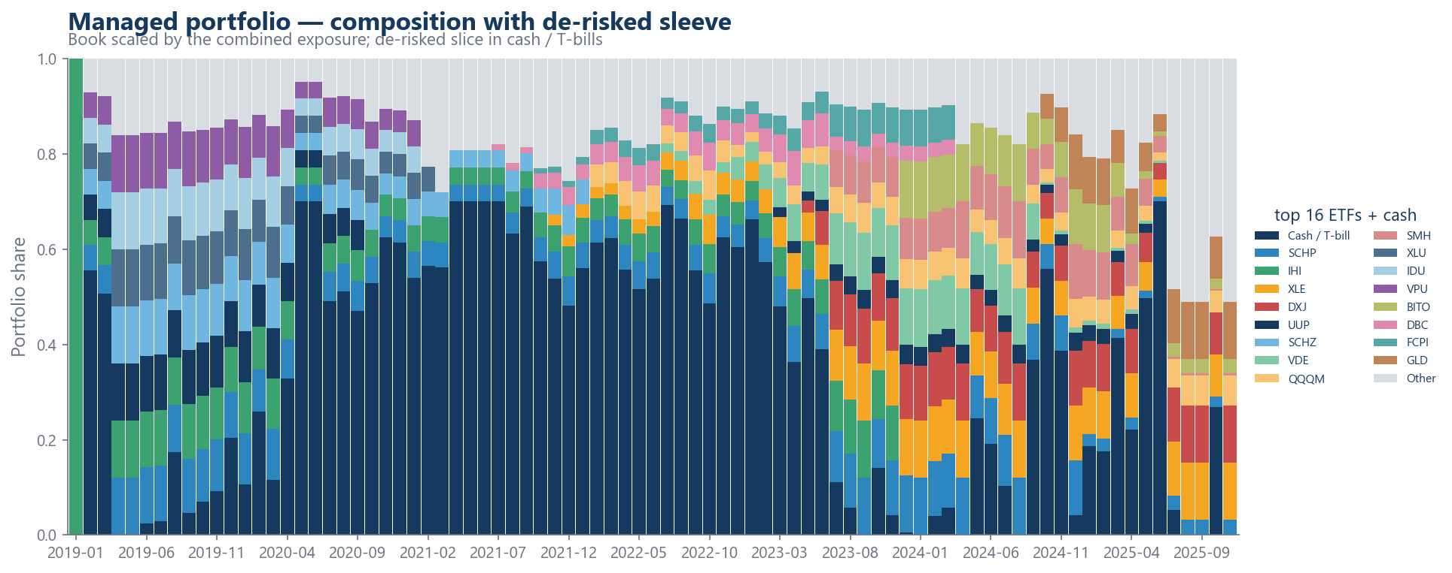

Turnover
Despite monthly re-optimisation, the strategy trades infrequently. The portfolio is left completely unchanged in 50 of 82 months (61%), and trading is concentrated in a small number of large rebalances: 15 months see turnover of 10% or more (up to 88%). The result is negligible cost: cumulative transaction cost over the seven-year sample is 0.47% of capital. This pattern reflects the corner-solution nature of the linear-programming allocator (its optimal vertex is stable until the estimated inputs cross a threshold) together with the partial-rebalancing execution, which moves the book only part of the way to each target.
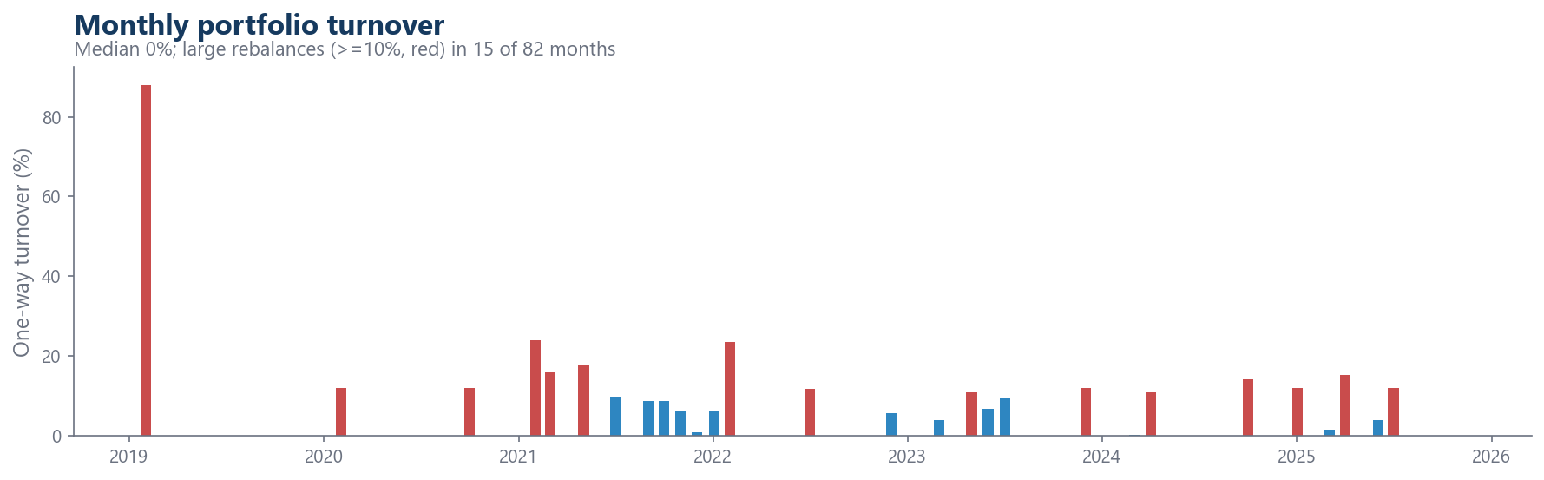

Dynamic optimizer parameters
The dynamic-parameter controller adjusts two optimiser settings each month: the CVaR confidence level α and the L1 turnover penalty λ — from a score `s_t = 0.70·(performance) + 0.30·(market regime)` bounded to [−1, 1]. Figure 6.5 plots their realised paths. Over the sample, α moved within [0.920, 0.972] around its base of 0.95 and λ within [0.0100, 0.0138] around its base of 0.01, with the driving score ranging from −0.44 to +0.59.
The two parameters behave as a risk measure that moves inversely with the regime. In the 2020 and 2022 risk-off episodes the score turns negative, which pushes α up toward 0.97, sending the CvaR constraint deeper into the tail and tightening the self-scaling budget and λ down to its 0.01 floor, making it cheaper for the optimiser to reposition out of risk. In calm, positive-score periods the moves reverse (α drifts toward 0.92, λ rises toward 0.0138). Because α defines both the constraint and the budget, this tilts the book toward more tail-robust allocations precisely when the market deteriorates. Empirically the α channel is the active one; λ spends much of the stressed periods pinned at its floor.
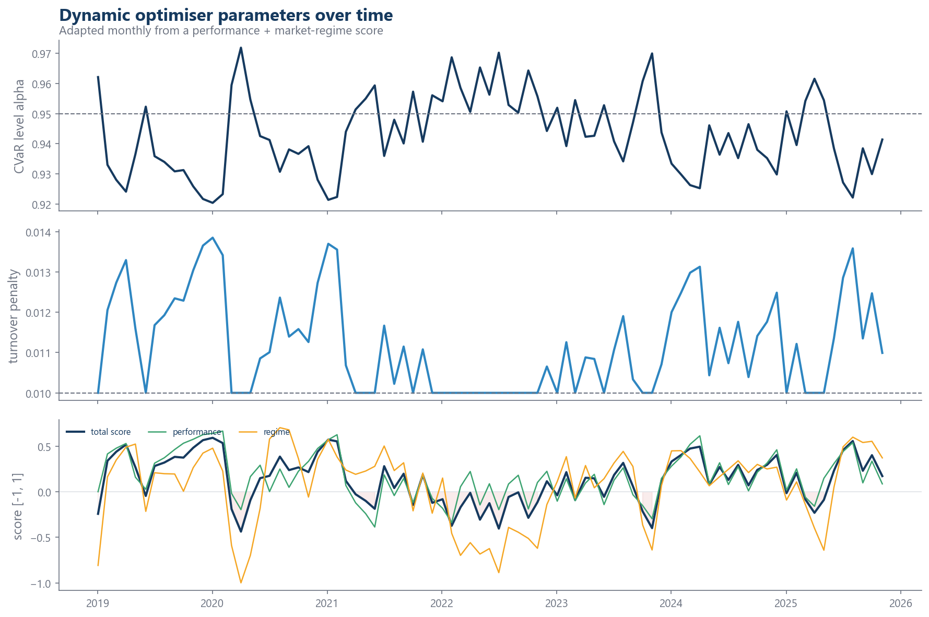

How the controller performed, and its significance
Enabling the controller improves the risk-adjusted performance: it lifts the Sharpe ratio from 0.624 (Static) to 0.704 (Dynamic base) and reduces the maximum drawdown from −19.3% to −17.6% (Table 6.1). The effect is economically sensible - the controller tightens tail control in exactly the stress months visible in the score panel of Figure 6.5 But it is a secondary contributor: the improvement, while consistent in direction, is modest in magnitude relative to the overlay, and the bulk of the risk reduction in the managed portfolio is delivered by the combined volatility/CVaR-timing overlay rather than by the parameter adaptation. The decisive, bootstrap-significant effects in this study (the drawdown reductions of §6.1) are attributable to the overlay. The controller's role is to make the allocation itself modestly more responsive to the cycle.

References
Artzner, P., Delbaen, F., Eber, J.-M., & Heath, D. (1999). Coherent measures of risk. Mathematical Finance, 9(3), 203–228. https://doi.org/10.1111/1467-9965.00068
Bailey, D. H., & López de Prado, M. (2014). The deflated Sharpe ratio: Correcting for selection bias, backtest overfitting, and non-normality. The Journal of Portfolio Management, 40(5), 94–107. https://doi.org/10.3905/jpm.2014.40.5.094
Ban, G.-Y., El Karoui, N., & Lim, A. E. B. (2018). Machine learning and portfolio optimization. Management Science, 64(3), 1136–1154. https://doi.org/10.1287/mnsc.2016.2644
Barroso, P., & Saxena, K. (2022). Lest we forget: Learn from out-of-sample forecast errors when optimizing portfolios. The Review of Financial Studies, 35(3), 1222–1278. https://doi.org/10.1093/rfs/hhab041
Bauder, D., Bodnar, T., Parolya, N., & Schmid, W. (2021). Bayesian mean–variance analysis: Optimal portfolio selection under parameter uncertainty. Quantitative Finance, 21(2), 221–242. https://doi.org/10.1080/14697688.2020.1748214
Bianchi, M. L., & Tassinari, G. L. (2020). Forward-looking portfolio selection with multivariate non-Gaussian models. Quantitative Finance, 20(10), 1645–1661. https://doi.org/10.1080/14697688.2020.1733057
Bodnar, T., Lindholm, M., Niklasson, V., & Thorsén, E. (2022). Bayesian portfolio selection using VaR and CVaR. Applied Mathematics and Computation, 427, 127120. https://doi.org/10.1016/j.amc.2022.127120
Carvalho, C. M., Polson, N. G., & Scott, J. G. (2010). The horseshoe estimator for sparse signals. Biometrika, 97(2), 465–480. https://doi.org/10.1093/biomet/asq017
Cederburg, S., O'Doherty, M. S., Wang, F., & Yan, X. S. (2020). On the performance of volatility-managed portfolios. Journal of Financial Economics, 138(1), 95–117. https://doi.org/10.1016/j.jfineco.2020.04.015
De Nicolò, G. (2023). Tail risk-managed portfolios [Working paper]. SSRN. https://doi.org/10.2139/ssrn.4320434
DeMiguel, V., Garlappi, L., & Uppal, R. (2009). Optimal versus naive diversification: How inefficient is the 1/N portfolio strategy? The Review of Financial Studies, 22(5), 1915–1953. https://doi.org/10.1093/rfs/hhm075
DeMiguel, V., Martín-Utrera, A., & Uppal, R. (2024). A multifactor perspective on volatility-managed portfolios. The Journal of Finance, 79(6), 3859–3891. https://doi.org/10.1111/jofi.13395
Garlappi, L., Uppal, R., & Wang, T. (2007). Portfolio selection with parameter and model uncertainty: A multi-prior approach. The Review of Financial Studies, 20(1), 41–81. https://doi.org/10.1093/rfs/hhl003
Gelmini, M., & Uberti, P. (2024). The equally weighted portfolio still remains a challenging benchmark. International Economics, 179, 100525. https://doi.org/10.1016/j.inteco.2024.100525
Gotoh, J.-Y., Shinozaki, K., & Takeda, A. (2013). Robust portfolio techniques for mitigating the fragility of CVaR minimization and generalization to coherent risk measures. Quantitative Finance, 13(10), 1621–1635. https://doi.org/10.1080/14697688.2012.738930
Happersberger, D., Lohre, H., & Nolte, I. (2020). Estimating portfolio risk for tail risk protection strategies. European Financial Management, 26(4), 1107–1146. https://doi.org/10.1111/eufm.12256
Harvey, C. R., Liu, Y., & Zhu, H. (2016). … and the cross-section of expected returns. The Review of Financial Studies, 29(1), 5–68. https://doi.org/10.1093/rfs/hhv059
Kita, A., Ronchetti, D., & Zhang, Y. (2023). Option-based volatility timing [Working paper]. SSRN. https://doi.org/10.2139/ssrn.4391540
Kostakis, A., Panigirtzoglou, N., & Skiadopoulos, G. (2011). Market timing with option-implied distributions: A forward-looking approach. Management Science, 57(7), 1231–1249. https://doi.org/10.1287/mnsc.1110.1346
Lassance, N., Martín-Utrera, A., & Simaan, M. (2024). The risk of expected utility under parameter uncertainty. Management Science, 70(11), 7644–7663. https://doi.org/10.1287/mnsc.2023.00178
Le, T. H. (2020). Forecasting value at risk and expected shortfall with mixed data sampling. International Journal of Forecasting, 36(4), 1362–1379. https://doi.org/10.1016/j.ijforecast.2020.01.008

Ledoit, O., & Wolf, M. (2004). Honey, I shrunk the sample covariance matrix. The Journal of Portfolio Management, 30(4), 110–119. https://doi.org/10.3905/jpm.2004.110
Lim, A. E. B., Shanthikumar, J. G., & Vahn, G.-Y. (2011). Conditional value-at-risk in portfolio optimization: Coherent but fragile. Operations Research Letters, 39(3), 163–171. https://doi.org/10.1016/j.orl.2011.03.004
Lyócsa, Š., Plíhal, T., & Výrost, T. (2024). Forecasting day-ahead expected shortfall on the EUR/USD exchange rate: The (i)relevance of implied volatility. International Journal of Forecasting, 40(4), 1275–1301. https://doi.org/10.1016/j.ijforecast.2023.11.003
Mansini, R., Ogryczak, W., & Speranza, M. G. (2007). Conditional value at risk and related linear programming models for portfolio optimization. Annals of Operations Research, 152(1), 227–256. https://doi.org/10.1007/s10479-006-0142-4
Markowitz, H. (1952). Portfolio selection. The Journal of Finance, 7(1), 77–91. https://doi.org/10.1111/j.1540-6261.1952.tb01525.x
Moreira, A., & Muir, T. (2017). Volatility-managed portfolios. The Journal of Finance, 72(4), 1611–1644. https://doi.org/10.1111/jofi.12513
Nakagawa, K., & Ito, K. (2021). Taming tail risk: Regularized multiple β worst-case CVaR portfolio. Symmetry, 13(6), 922. https://doi.org/10.3390/sym13060922
Pflug, G. C. (2000). Some remarks on the value-at-risk and the conditional value-at-risk. In S. Uryasev (Ed.), Probabilistic constrained optimization: Methodology and applications (pp. 272–281). Springer. https://doi.org/10.1007/978-1-4757-3150-7_15
Rickenberg, L. (2019). Tail risk targeting: Target VaR and CVaR strategies [Working paper]. SSRN. https://doi.org/10.2139/ssrn.3444999
Rockafellar, R. T., & Uryasev, S. (2000). Optimization of conditional value-at-risk. The Journal of Risk, 2(3), 21–41. https://doi.org/10.21314/JOR.2000.038
Rockafellar, R. T., & Uryasev, S. (2001). Conditional value-at-risk: Optimization approach. In S. Uryasev & P. M. Pardalos (Eds.), Stochastic optimization: Algorithms and applications (pp. 411–435). Springer. https://doi.org/10.1007/978-1-4757-6594-6_17
Schwalbach, B., & Auret, C. (2023). Leveraging defence into offence: Enhancing absolute and risk-adjusted equity returns with tail risk management overlays. Investment Analysts Journal, 52(3), 246–258. https://doi.org/10.1080/10293523.2023.2245243
Suhonen, A., Lennkh, M., & Perez, F. (2017). Quantifying backtest overfitting in alternative beta strategies. The Journal of Portfolio Management, 43(2), 90–104. https://doi.org/10.3905/jpm.2017.43.2.090
Taylor, J. W. (2019). Forecasting value at risk and expected shortfall using a semiparametric approach based on the asymmetric Laplace distribution. Journal of Business & Economic Statistics, 37(1), 121–133. https://doi.org/10.1080/07350015.2017.1281815
Wang, F., & Yan, X. S. (2021). Downside risk and the performance of volatility-managed portfolios. Journal of Banking & Finance, 131, 106198. https://doi.org/10.1016/j.jbankfin.2021.106198
Wiecki, T., Campbell, A., Lent, J., & Stauth, J. (2016). All that glitters is not gold: Comparing backtest and out-of-sample performance on a large cohort of trading algorithms. The Journal of Investing, 25(3), 69–80. https://doi.org/10.3905/joi.2016.25.3.069
Yuan, M., & Zhou, G. (2023). Why naive 1/N diversification is not so naive, and how to beat it? Journal of Financial and Quantitative Analysis, 59(8), 3601–3632. https://doi.org/10.1017/S0022109023001175

